What is HTTP and how does it work?
In the starting days of internet, network administrators had to figure out how to share the information they put out on the Internet. They agreed on a procedure for exchanging information and called it HyperText Transfer Protocol (HTTP). The Hypertext Transfer Protocol (HTTP) is designed to enable communications between clients and servers. HTTP works as a request-response protocol between a client and server. A web browser may be the client, and an application on a computer that hosts a web site may be the server.
Example: A client (browser) submits an HTTP request to the server; then the server returns a response to the client. The response contains status information about the request and may also contain the requested content.
Commonly used HTTP request methods:
GET:
- Requests data from a specified resource.
- It is for retrieving data.
- It should have no side effects, you should be able to request the same URL over and over harmlessly.
- GET requests can be cached.
- GET requests remain in the browser history.
- GET requests can be bookmarked.
- GET requests should never be used when dealing with sensitive data.
- GET requests have length restrictions.
- GET requests should be used only to retrieve data.
POST:
- Submits data to be processed to a specified resource.
- It is for writing data.
- It may have side effects. Making multiple identical write requests will likely result in multiple writes. Browsers typically give you warnings about this.
- POST is *not* secure. The data is in the body of the request instead of the URL but it doesn’t mean that it is secure. It is trivially simple to view/edit.
- POST requests are never cached.
- POST requests do not remain in the browser history.
- POST requests cannot be bookmarked.
- POST requests have no restrictions on data length.
Put: It is for editing/updating data. It should alter an existing object rather than create a new object. Like POST it typically puts data in the body of the request.
Delete: Delete is for removing data. It typically uses the URL rather than placing data in the body.
Options: Returns the HTTP methods that the server supports
Head: Same as GET but returns only HTTP headers and no document body
Connect: Converts the request connection to a transparent TCP/IP tunnel

What is HTTPS and what does it do?
In the starting days of internet, network administrators had to figure out how to share the information they put out on the Internet. They agreed on a procedure for exchanging information and called it HyperText Transfer Protocol (HTTP). Once everyone knew how to exchange information, intercepting on the Internet was not difficult. So knowledgeable administrators agreed upon a procedure to protect the information they exchanged. The protection relies on SSL/TLS (Secure Sockets Layer / Transport Layer Security) encryption of the online data. The procedure for encrypting information and then exchanging it is called HyperText Transfer Protocol Secure (HTTPS).

Thus, HTTPS takes the well-known and understood HTTP protocol, and simply layers a SSL/TLS (hereafter referred to simply as “SSL”) encryption layer on top of it. Servers and clients still speak exactly the same HTTP to each other, but over a secure SSL connection that encrypts and decrypts their requests and responses. The SSL layer has 2 main purposes:

Verifying that you are talking directly to the server that you think you are talking to

Ensuring that only the server can read what you send it and only you can read what it sends back

The really, really clever part is that anyone can intercept every single one of the messages you exchange with a server, including the ones where you are agreeing on the key and encryption strategy to use, and still not be able to read any of the actual data you send.

How https works for the sites which uses https?
Suppose we are going to visit gmail as an example:
- My laptop tries to connect to the Gmail server and sends an http request.
- Gmail server replies with a request to establish https connection instead. (If the client had made https request itself in the first step, then also the server replies the same).
- This reply from the gmail comes to the client browser in the form of a certificate signed by the CA (Certification Authority). (CA is generally extremely secure, reliable and trustworthy organisations like Symantec, Comodo and GoDaddy).
- An SSL certificate contains various pieces of data, including the name of the owner, the property (eg. domain) it is attached to, the certificate’s public key, the digital signature and information about the certificate’s validity dates.
- Your browser verifies the evidence in the certificate, to confirm that this certificate has been sent by the gmail.com by checking from the certification authority. The browsers have built in root certificates for these CA which they use to validate the website.
- Your browser chooses a random new symmetric key K to use for its connection to Gmail. It encrypts K under Gmail's public key. (Symmetric-key algorithms are algorithms for cryptography that use the same cryptographic keys for both encryption of plaintext and decryption of ciphertext.)
- Gmail decrypts K using its private key. Now both your browser and the Gmail server know K, but no one else does.
- Anytime your browser wants to send something to Gmail, it encrypts it under K; the Gmail server decrypts it upon receipt. Anytime the Gmail server wants to send something to your browser, it encrypts it under K.

HTTPS is more secure, so why isn’t the Web using it?
- HTTPS has been around nearly as long as the Web, but it's primarily used by sites that handle money—your bank's website or shopping carts that capture credit card data.
- Even many sites that do use HTTPS only use it for the portions of their websites that need it—like shopping carts or account pages.
- But now even sites like Twitter, which has almost entirely public data anyway, is nevertheless offering HTTPS connections.
- Google has even announced it will adding HTTPS to many of the company's APIs.
- Firefox users can go a step further and use the HTTPS Everywhere add-on to force HTTPS connections to several dozen websites that all offer HTTPS, but don't use it by default.
So the Web is clearly moving toward more HTTPS connections; why not just make everything HTTPS? Some of the reasons for this are:
- Perhaps the main reason most of us are not using HTTPS to serve our websites is simply that it doesn't work with virtual hosts. Virtual hosts, which are what the most common cheap Web hosting providers offer, allow the Web host to serve multiple websites from the same physical server—hundreds of websites all with the same IP address. That works just fine with regular HTTP connections, but it doesn't work at all with HTTPS.
- There is a way to make virtual hosting and HTTPS work together—the TLS Extensions protocol—but so far, it's only partially implemented.
- The important problem is that with HTTPS you lose the ability to cache and so the response time will be large.
- There is another small performance hit when using HTTPS, since "the SSL initial key exchange adds to the latency." In other words, a purely security-focused, HTTPS-only Web would, with today's technology, be slower. (But the fact that more and more websites are adding support of HTTPS shows that users do value security over speed, so long as the speed difference is minimal.)
- For sites that don't have any reason to encrypt anything—in other words, you never log in, so there's nothing to protect—the overhead and loss of caching that comes with HTTPS just doesn't make sense.
- Another problem with running an HTTPS site is the cost of operations. Although servers are faster and implementations of SSL more optimized, it still costs more than doing plain http.
- Some websites are probably aware of, such as the high cost of secure certificates.
In the end there is no real reason the whole Web couldn't use HTTPS. There are practical reasons why it isn't happening today, but eventually the practical hurdles will fall away. Broadband speeds will improve, making caching less of a concern, and improved servers will be further optimized for secure connections. In the Web of the future the main concern won't just be how fast a site loads, but how well it safeguards you and protects your data once it does load.

What steps must be followed to send password securely from the user registration page (i.e. client side) to the server over a non encrypted channel (http) when the user registers for the first time on the website?
The only safe method for a website to transfer a password to the server is using HTTPS/SSL. If the connection itself is not encrypted, an ManInTheMiddle can modify or strip away any JavaScript sent to the client. So you cannot rely on client side hashing.
You cannot setup a secure connection between client and server on your own, because there is no already shared information. This is like inventing a secret language while the bad guy is listening. That's what SSL is for, if you get an SSL cert for your website from a public CA, then the browsers have built in root certificates for these CA which they use to validate your website. Based on that, the client and server can set up a secure connection.

Is it safe to send clear usernames/passwords on a https connnection to authenticate user?
Yes, this is the standard practice. Doing anything other than this offers minimal additional advantage, if any (and in some cases may harm the security). As long as you verify a valid SSL connection to the correct server, then the password is protected on the wire and can only be read by the server. You don't gain anything by disguising the password before sending it as the server can not trust the client.

How to keep password safe in the database?
From time to time, servers and databases are stolen or compromised. With this in mind, it is important to ensure that some crucial user data, such as passwords, can not be recovered.
How this can be accomplished?
This is accomplished by using a one-way hash function. "One-way" means that it is very difficult (or practically impossible) to reverse it.
A common example of one-way hash function is md5():
- which is quite popular in many different languages and systems.
$data = "Hello World";
$hash = md5($data);
echo $hash; // b10a8db164e0754105b7a99be72e3fe
- With md5(), the result will always be a 32 character long string. But, it contains only hexadecimal characters; technically it can also be represented as a 128-bit (16 byte) integer.
- You may md5() much longer strings and data, and you will still end up with a hash of this length. This fact alone might give you a hint as to why this is considered a "one-way" function.
How password is stored during registration and verified during login:
The usual process during a user registration:
- User fills out registration form, including the password field.
- The web script stores all of the information into a database.
- However, the password is run through a hash function, before being stored.
- The original version of the password has not been stored anywhere, so it is technically discarded.
And the login process:
- User enters username (or e-mail) and password.
- The script runs the password through the same hashing function.
- The script finds the user record from the database, and reads the stored hashed password.
- Both of these values are compared, and the access is granted if they match.
As we said that the original password has never been stored anywhere. If the database is stolen, the user logins can not be compromised, right? Well, the answer is "it depends." Let's look at some potential problems even after hashing:
- Hash Collision: A hash "collision" occurs when two different data inputs generate the same resulting hash. The likelihood of this happening depends on which function you use.
How can this be exploited?
As an example, I have seen some older scripts which used crc32() to hash passwords. This function generates a 32-bit integer as the result. This means there are only 2^32 (i.e. 4,294,967,296) possible outcomes. Let's hash a password:
echo crc32('supersecretpassword');
// outputs: 323322056
Now, let's assume the role of a person who has stolen a database, and has the hash value. We may not be able to convert 323322056 into 'supersecretpassword', however, we can figure out another password that will convert to the same hash value, with a simple script:
set_time_limit(0);
$i = 0;
while (true) {

if (crc32(base64_encode($i)) == 323322056) {
echo base64_encode($i);
exit;
}

$i++;
}
This may run for a while, though, eventually, it will return a string which will have the same crc32() value and we can login using this string.
How can this be prevented?
Nowadays, a powerful home PC can be used to run a hash function almost a billion times per second. So we need a hash function that has a very big range. For example, md5() might be suitable, as it generates 128-bit hashes. This translates into 340,282,366,920,938,463,463,374,607,431,768,211,456 possible outcomes. It is impossible to run through so many iterations to find collisions. However some people have still found ways to do this. Sha1() is a better alternative, and it generates an even longer 160-bit hash value.
But even if we fix the collision issue, we're still not safe yet. See the another potential problem.
- Rainbow table: A rainbow table is built by calculating the hash values of commonly used words and their combinations. These tables can have as many as millions or even billions of rows. For example, you can go through a dictionary, and generate hash values for every word. You can also start combining words together, and generate hashes for those too. That is not all; you can even start adding digits before/after/between words, and store them in the table as well. Considering how cheap storage is nowadays, gigantic Rainbow Tables can be produced and used.
How can this be exploited?
Let's imagine that a large database is stolen, along with 10 million password hashes. It is fairly easy to search the rainbow table for each of them. Not all of them will be found, certainly, but, nonetheless...some of them will!
How can this be prevented?
We can try adding a "salt". Here is an example:
$password = "easypassword";

// this may be found in a rainbow table
// because the password contains 2 common words
echo sha1($password); // 6c94d3b42518febd4ad747801d50a8972022f956

// use bunch of random characters, and it can be longer than this
$salt = "f#@V)Hu^%Hgfds";

// this will NOT be found in any pre-built rainbow table
echo sha1($salt . $password); // cd56a16759623378628c0d9336af69b74d9d71a5

What we basically do is concatenate the "salt" string with the passwords before hashing them. The resulting string obviously will not be on any pre-built rainbow table. But, we're still not safe just yet! Remember that a Rainbow Table may be created from scratch, after the database has been stolen.
How can this be exploited?
Even if a salt was used, this may have been stolen along with the database. All they have to do is generate a new Rainbow Table from scratch, but this time they concatenate the salt to every word that they are putting in the table.
For example, in a generic Rainbow Table, "easypassword" may exist. But in this new Rainbow Table, they have "f#@V)Hu^%Hgfdseasypassword" as well. When they run all of the 10 million stolen salted hashes against this table, they will again be able to find some matches.
How can this be prevented?
We can use a "unique salt" instead, which changes for each user. A candidate for this kind of salt is the user's id value from the database:
$hash = sha1($user_id . $password);
This is assuming that a user's id number never changes, which is typically the case. We may also generate a random string for each user and use that as the unique salt. But we would need to ensure that we store that in the user record somewhere.
// generates a 22 character long random string
function unique_salt() {

return substr(sha1(mt_rand()),0,22);
}

$unique_salt = unique_salt();

$hash = sha1($unique_salt . $password);

// and save the $unique_salt with the user record
// …
This method protects us against Rainbow Tables, because now every single password has been salted with a different value. The attacker would have to generate 10 million separate Rainbow Tables, which would be completely impractical.
- Hash Speed: Most hashing functions have been designed with speed in mind, because they are often used to calculate checksum values for large data sets and files, to check for data integrity.
How can this be exploited?
As I mentioned before, a modern PC with powerful GPU's (yes, video cards) can be programmed to calculate roughly a billion hashes per second. This way, they can use a brute force attack to try every single possible password. You may think that requiring a minimum 8 character long password might keep it safe from a brute force attack, but let's determine if that is, indeed, the case:
If the password can contain lowercase, uppercase letters and number, that is 62 (26+26+10) possible characters.
- An 8 character long string has 62^8 possible versions. That is a little over 218 trillion.
- At a rate of 1 billion hashes per second, that can be solved in about 60 hours.
- And for 6 character long passwords, which is also quite common, it would take under 1 minute.
Feel free to require 9 or 10 character long passwords, however you might start annoying some of your users.
How can this be prevented?
Use a slower hash function.
Imagine that you use a hash function that can only run 1 million times per second on the same hardware, instead of 1 billion times per second. It would then take the attacker 1000 times longer to brute force a hash. 60 hours would turn into nearly 7 years!
One way to do that would be to implement it yourself:
function myhash($password, $unique_salt) {

$salt = "f#@V)Hu^%Hgfds";
$hash = sha1($unique_salt . $password);

// make it take 1000 times longer
for ($i = 0; $i < 1000; $i++) {
$hash = sha1($hash);
}

return $hash;
}
Or you may use an algorithm that supports a "cost parameter," such as BLOWFISH. In PHP, this can be done using the crypt() function.
function myhash($password, $unique_salt) {

// the salt for blowfish should be 22 characters long

return crypt($password, '$2a$10$'.$unique_salt);

}
The second parameter to the crypt() function contains some values separated by the dollar sign ($). The first value is '$2a', which indicates that we will be using the BLOWFISH algorithm. The second value, '$10' in this case, is the "cost parameter". This is the base-2 logarithm of how many iterations it will run (10 => 2^10 = 1024 iterations.) This number can range between 04 and 31.
function myhash($password, $unique_salt) {
return crypt($password, '$2a$10$'.$unique_salt);

}
function unique_salt() {
return substr(sha1(mt_rand()),0,22);
}

$password = "verysecret";

echo myhash($password, unique_salt());
// result: $2a$10$dfda807d832b094184faeu1elwhtR2Xhtuvs3R9J1nfRGBCudCCzC
The resulting hash contains the algorithm ($2a), the cost parameter ($10), and the 22 character salt that was used. The rest of it is the calculated hash.
This way we can secure the password. All the things what we have learned upto this time can be summarized as follows:
Here is what we do during user registration:
// include the class required to make hash of password
require ("PassHash.php");
// read all form input from $_POST
// ...
// do your regular form validation stuff
// ...
// hash the password
$pass_hash = PassHash::hash($_POST['password']);
// store all user info in the DB, excluding $_POST['password']
// store $pass_hash instead

The utility class for hashing the password:
class PassHash {
// blowfish
private static $algo = '$2a';

// cost parameter
private static $cost = '$10';

// mainly for internal use
public static function unique_salt() {
return substr(sha1(mt_rand()),0,22);
}

// this will be used to generate a hash
public static function hash($password) {
return crypt($password,
self::$algo .
self::$cost .
'$' . self::unique_salt());
}

// this will be used to compare a password against a hash
public static function check_password($hash, $password) {
$full_salt = substr($hash, 0, 29);
$new_hash = crypt($password, $full_salt);
return ($hash == $new_hash);
}
}
And here is what we do during login of the user:
// include the class
require ("PassHash.php");

// read all form input from $_POST
// ...

// fetch the user record based on $_POST['username'] or similar
// ...

// check the password the user tried to login with
if (PassHash::check_password($user['pass_hash'], $_POST['password']) {
// grant access
// ...
} else {
// deny access
// ...
}

What is a session? How session is maintained at the server end?
“session” is one of those computing terms that refers to seemingly different things : a shell session, a tcp session, a login session, a desktop session, a browser session, a server session etc. This makes it confusing to understand what exactly a session is. Same for the “cache”, another confusing term (database cache, browser cache, framework cache, network cache..). But actually what defines those confusing terms is the use they’re describing.
So, the first thing to understand for sessions is their use.
Use of a session
Generally you should understand the session as the different states of an application during the time a user is interacting with it, it is specific to the user. I would even say a session is an instance of the interaction of a user with an application for the particular time. Now more specifically for a web session, the session is a data structure that an application uses to store temporary data that is useful only during the time a user is interacting with the application, it is also specific to the user. Think of it as a volatile memory quickly accessible that is allocated to each user who is using the application, and when the user quits, it is destroyed. The session id only identifies your connection to the server.
This is the general concept. The storage mechanism and how it is implemented is then specific to the application. This temporary storage could be on the file system in text files, on a database or in the internal memory of the program executing the application.
The second thing to understand is the structure of a session.
Structure of a session
The session is a key-value pair data structure. Think of it as a hashtable where each user gets a hashkey to put their data in. This hashkey would be the “session id”. A session data structure would look like this :
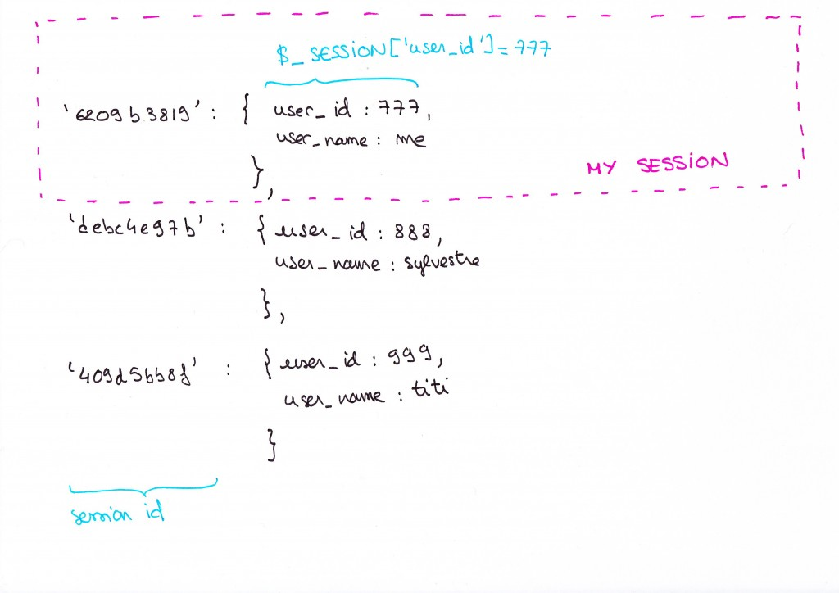
Session datastructure
And when you say, “my session” you would refer to your entry in the session object. Every user is able to access only their session. The session can be stored on the server, or on the client. If it’s on the client, it will be stored by the browser, most likely in cookies and if it is stored on the server, the session ids are created and managed by the server. So if there are a million users connected to the server, there will also be a million session ids for those users on the server.
From now, I will focus only on server side sessions.
How does a session work ?
So how exactly do users access their session? For a single user application, like a desktop application, there is only one user, so there is also one session, it is not difficult for the application to make the connection between the user and their session data. However, for a web application, a server has multiple clients, how does it know which session is yours? That’s where the session id comes into play.
The general principle is that you, as the client, give the server your session id, and in return the server grants you access to your session data if it finds your session id stored in its session datastore. The session structure is like a data locker for users, and the key for the locker is the session id, the server is the guy who shows you which one is your locker.
Let’s look more in details how it works :
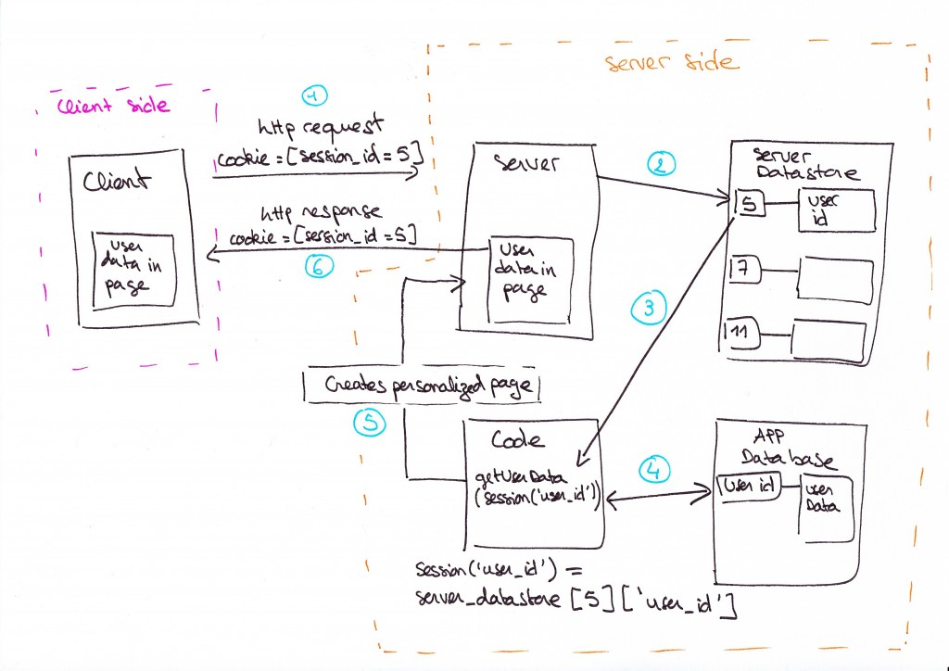
How does a session work ?
Let’s start from the moment when you land on a webpage. When you receive a webpage from the server, along with the page content itself, the server sent you (in general, in a cookie) the session id that it set to identify your connection among all the requests that it gets.
Make the experiment, open your console and check the cookies, you will see something that looks like :
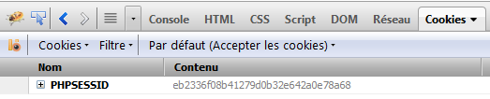
Php session id
JSP will send you JSESSIONID, and ASP ASPSESSIONID, here the back end is PHP.
After you logged in, the application validated your password and login and saved your user id in the session so that every time you will make a request, you won’t have to log in again.
Now let’s review the diagram above to understand what is going on when you make another request to get more data. For example, let’s say you landed on Gmail inbox after you logged in, and now you want to navigate to your drafts page.
1 – You send a http request to the server asking for the drafts page. Along with this http request you send your session id to tell the server “hey, it’s me from before, give me my drafts page now”. The session id is usually sent in cookies, but it can also be sent in GET or POST parameters, whatever the technique the session id just needs to be sent to the server.
2 – The server receives your request. Before it gives you your drafts page, it checks your session id, looks it up in its session datastore, it finds 5, your session id, so it makes the data in entry 5 available to the code engine (php, java, ruby…).
3 -The server then executes the code corresponding to your request “give me the drafts page”.
4 – The code starts by getting your user id from the session made available by the server earlier, then it uses it to ask the database “give me the drafts of the user who has this user id”.
5 – Finally when the code got your drafts from the database, it creates an html page, puts your drafts in it, and hands it to the server.
6 – The server sends you your drafts page, along with your session id.
Logged in state
Session management is a feature of the server, you need to activate it. For a static website that doesn’t serve private data for example you would not need to activate session management on your server.
Keeping you logged in is one main use of the session, but sessions can also be used to save temporary data that are completely independent of the logged in state. You could decide to put some data in session just because it is quicker to access.
Also as a side note, from the server’s point of view : one connection = one session id. So if you connect from two different browsers, the server will create two session ids. You should remember that the session id only identifies your connection to the server. All the user identification logic is handled by the application.

What is the difference between an application server and a Web server?
The Web server:
- A Web server handles the HTTP protocol. When the Web server receives an HTTP request, it responds with an HTTP response, such as sending back an HTML page.
- To process a request, a Web server may respond with a static HTML page or image, send a redirect, or delegate the dynamic response generation to some other program such as CGI scripts, JSPs (JavaServer Pages), servlets, ASPs (Active Server Pages), server-side JavaScripts, or some other server-side technology. Whatever their purpose, such server-side programs generate a response, most often in HTML, for viewing in a Web browser.
- Understand that a Web server's delegation model is fairly simple. When a request comes into the Web server, the Web server simply passes the request to the program best able to handle it. The Web server doesn't provide any functionality beyond simply providing an environment in which the server-side program can execute and pass back the generated responses. The server-side program usually provides for itself such functions as transaction processing, database connectivity, and messaging.
- While a Web server may not itself support transactions or database connection pooling, it may employ various strategies for fault tolerance and scalability such as load balancing, caching, and clustering—features oftentimes erroneously assigned as features reserved only for application servers.

The application server:

An application server exposes business logic to client applications through various protocols, possibly including HTTP. While a Web server mainly deals with sending HTML for display in a Web browser, an application server provides access to business logic for use by client application programs. The application program can use this logic just as it would call a method on an object (or a function in the procedural world).

Such application server clients can include GUIs (graphical user interface) running on a PC, a Web server, or even other application servers. The information traveling back and forth between an application server and its client is not restricted to simple display markup. Instead, the information is program logic. Since the logic takes the form of data and method calls and not static HTML, the client can employ the exposed business logic however it wants.

In most cases, the server exposes this business logic through a component API, such as the EJB (Enterprise JavaBean) component model found on J2EE (Java 2 Platform, Enterprise Edition) application servers.

Moreover, the application server manages its own resources. Such gate-keeping duties include security, transaction processing, resource pooling, and messaging. Like a Web server, an application server may also employ various scalability and fault-tolerance techniques.

An example: As an example, consider an online store that provides real-time pricing and availability information. Most likely, the site will provide a form with which you can choose a product. When you submit your query, the site performs a lookup and returns the results embedded within an HTML page. The site may implement this functionality in numerous ways. I'll show you one scenario that doesn't use an application server and another that does. Seeing how these scenarios differ will help you to see the application server's function.

Scenario 1: Web server without an application server

In the first scenario, a Web server alone provides the online store's functionality. The Web server takes your request, then passes it to a server-side program able to handle the request. The server-side program looks up the pricing information from a database or a flat file. Once retrieved, the server-side program uses the information to formulate the HTML response, then the Web server sends it back to your Web browser.

To summarize, a Web server simply processes HTTP requests by responding with HTML pages.

Scenario 2: Web server with an application server

Scenario 2 resembles Scenario 1 in that the Web server still delegates the response generation to a script. However, you can now put the business logic for the pricing lookup onto an application server. With that change, instead of the script knowing how to look up the data and formulate a response, the script can simply call the application server's lookup service. The script can then use the service's result when the script generates its HTML response.

In this scenario, the application server serves the business logic for looking up a product's pricing information. That functionality doesn't say anything about display or how the client must use the information. Instead, the client and application server send data back and forth. When a client calls the application server's lookup service, the service simply looks up the information and returns it to the client.

By separating the pricing logic from the HTML response-generating code, the pricing logic becomes far more reusable between applications. A second client, such as a cash register, could also call the same service as a clerk checks out a customer. In contrast, in Scenario 1 the pricing lookup service is not reusable because the information is embedded within the HTML page. To summarize, in Scenario 2's model, the Web server handles HTTP requests by replying with an HTML page while the application server serves application logic by processing pricing and availability requests.

Caveats

Recently, XML Web services have blurred the line between application servers and Web servers. By passing an XML payload to a Web server, the Web server can now process the data and respond much as application servers have in the past.

Additionally, most application servers also contain a Web server, meaning you can consider a Web server a subset of an application server.

While application servers contain Web server functionality, developers rarely deploy application servers in that capacity. Instead, when needed, they often deploy standalone Web servers in tandem with application servers. Such a separation of functionality aids performance (simple Web requests won't impact application server performance), deployment configuration (dedicated Web servers, clustering, and so on), and allows for best-of-breed product selection.
Difference between web server and application server in special context of Java:
On Java J2EE perspective main difference between web server and application server is support of EJB. In order to run EJB or host enterprise Java application (.ear) file you need an application server like JBoss, WebLogic, WebSphere or Glassfish, while you can still run your servlet and JSP or java web application (.war) file inside any web server like Tomcat or Jetty.
Application Server vs Web Server:
1. Application Server supports distributed transaction and EJB. While Web Server only supports Servlets and JSP.
2. Application Server can contain web server in them. most of App server e.g. JBoss or WAS has Servlet and JSP container.
3. Though its not limited to Application Server but they used to provide services like Connection pooling, Transaction management, messaging, clustering, load balancing and persistence. Now Apache tomcat also provides connection pooling.
4. In terms of logical difference between web server and application server: web server is supposed to provide http protocol level service while application server provides support to web service and expose business level service e.g. EJB.
5. Application server are more heavy than web server in terms of resource utilization.

